SIMATS ENGINEERING
ASSESSMENT TOOL 1

COURSE NAME: Data Warehousing and Data Mining
COURSE CODE :CSA1601

COURSE OUTCOME COVERED

CO1: Design data warehouse architectures with appropriate dimensional models for effective decision support systems.BL1,BL2
Assessment Tool Weightage: 50%

QUESTIONS: 5 Total Marks:25

Concept Mapping
Annexure A

Criteria | Concept Identification(2.5) | Linkages(2.5) | Organization(2) | Integration of Literature(2) | Clarity(1) | Total(10)
Weightage | 25% | 25% | 20% | 20% | 10% | 100%
Q1
Q2
Q3
Q4
Q5

Code of Conduct:

I MAHESH K .V(192421358) certify that this submission is my original work and that I have adhered to the guidelines specified for this assessment.
I understand that any violation of academic integrity rules will result in disciplinary action.

Signature of the student:
MAHESH K .V
RUBRICS FOR CALCULATION:

Concept Mapping
Criteria | Weightage | Level 4 (Exemplary) | Level 3 (Proficient) | Level 2 (Developing) | Level 1 (Beginning)
Concept Identification | 25% | Identifies all key concepts from literature accurately and comprehensively | Identifies most key concepts with minor omissions | Identifies limited concepts; some are irrelevant or missing | Fails to identify essential concepts
Linkages | 25% | Establishes clear, meaningful, and accurate relationships between concepts | Shows correct relationships with minor gaps | Relationships are weak, unclear, or partially incorrect | No meaningful relationships established
Organization | 20% | Concepts are well-structured hierarchically with logical flow and grouping | Mostly organized with minor structural issues | Some organization but lacks clear hierarchy | No logical organization or structure
Integration of Literature | 20% | Integrates multiple studies effectively to show connections and comparisons | Shows some integration of literature | Limited integration; mostly isolated concepts | No integration of literature evidence
Clarity | 10% | Concept map is clear, neat, visually structured, and easy to interpret | Generally clear with minor readability issues | Clarity is reduced; difficult to interpret in parts | Poorly presented and hard to understand

Annexure A

Concept Map 1: Decision Support Systems (DSS)

Task Description:
Construct a concept map that explains how a Decision Support System (DSS) supports organizational decision-making.

What your map must show:
- Core components: Data, Model, User Interface
- Types of DSS
- Flow: Data → Analysis → Decision
- Role in business decision-making
- Real-world example linkage
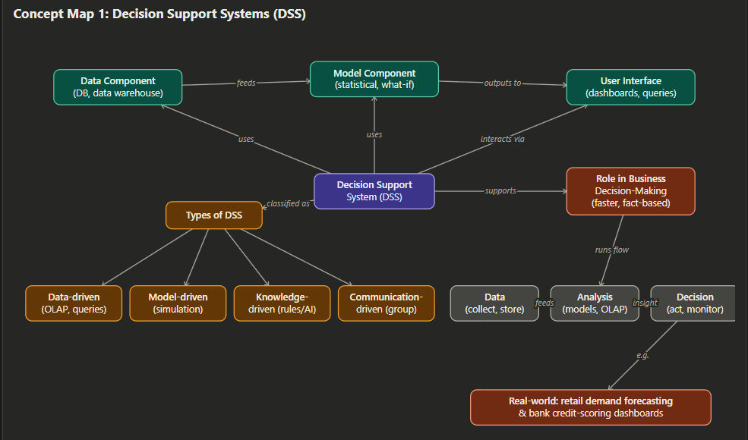

Concept Map 2: Operational Systems vs DSS

Task Description:
Develop a comparative concept map that clearly distinguishes Operational Systems (OLTP) and Decision Support Systems (OLAP).

What your map must show:
- Definitions of OLTP and DSS
- Differences (data type, purpose, users, processing)
- Similarities and interactions
- Real-time vs historical data
- Example systems (banking vs analytics)
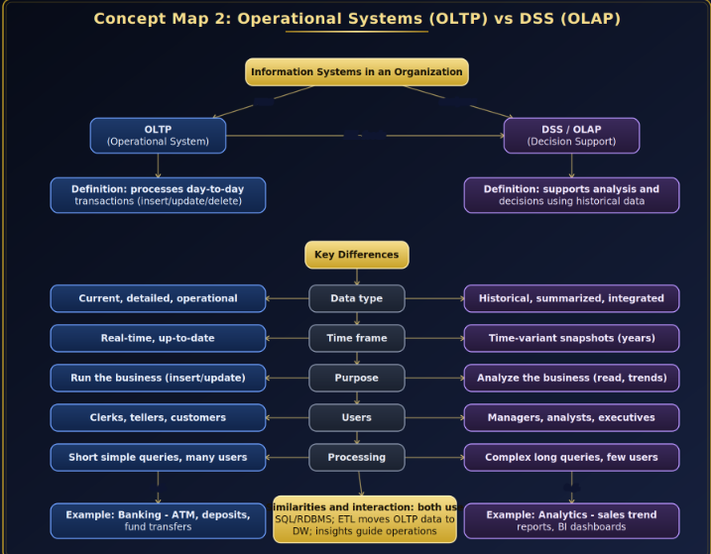

Concept Map 3: Architecture of Data Warehouse

Task Description:
Create a hierarchical concept map illustrating the architecture of a Data Warehouse.

What your map must show:
- Data Sources → ETL → Data Warehouse → Data Marts
- Metadata layer
- Front-end tools (reporting, OLAP)
- Data flow direction
- Role of each layer
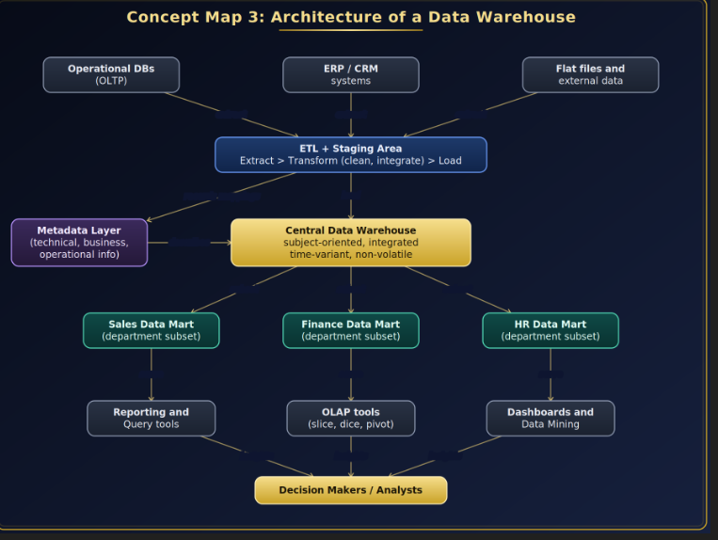

Concept Map 4: OLAP, Data Cubes & Dimensional Modeling

Task Description:
Design a concept map that connects OLAP operations, Data Cubes, and Dimensional Modeling techniques.

🎯 What your map must show:
- Data cube structure (dimensions, measures)
- OLAP operations (slice, dice, roll-up, drill-down)
- Star schema and snowflake schema
- Fact and dimension tables
- Analytical usage
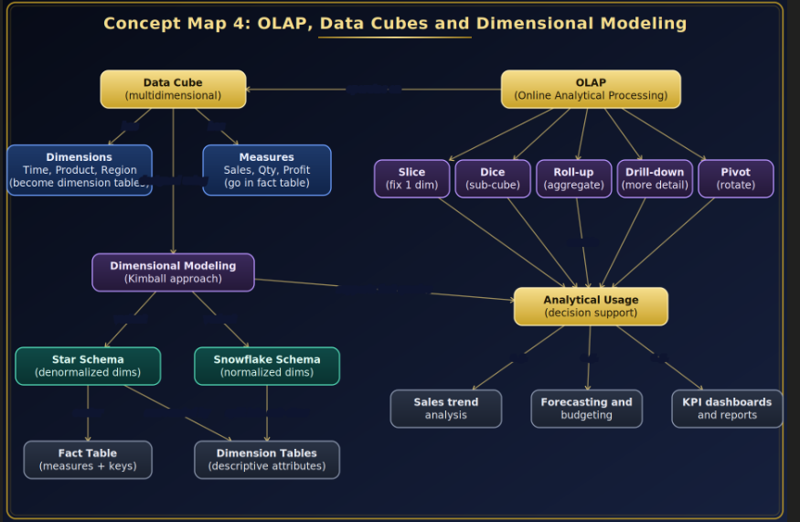

Concept Map 5: Query Processing & BI Tools (KNIME)

Task Description:
Construct a concept map explaining how query processing integrates with BI tools, focusing on KNIME for reporting and OLAP applications.

What your map must show:
- Query processing stages (Parsing, Optimization, Execution)
- Role of BI tools
- KNIME workflow structure
- Data → Query → Visualization pipeline
- OLAP application integration

